Kickstarter Written Analysis Questions

1. Three Conclusions:
2. The most common Kickstarter projects are Theater projects, followed by Music, Tech, and Film & Video.

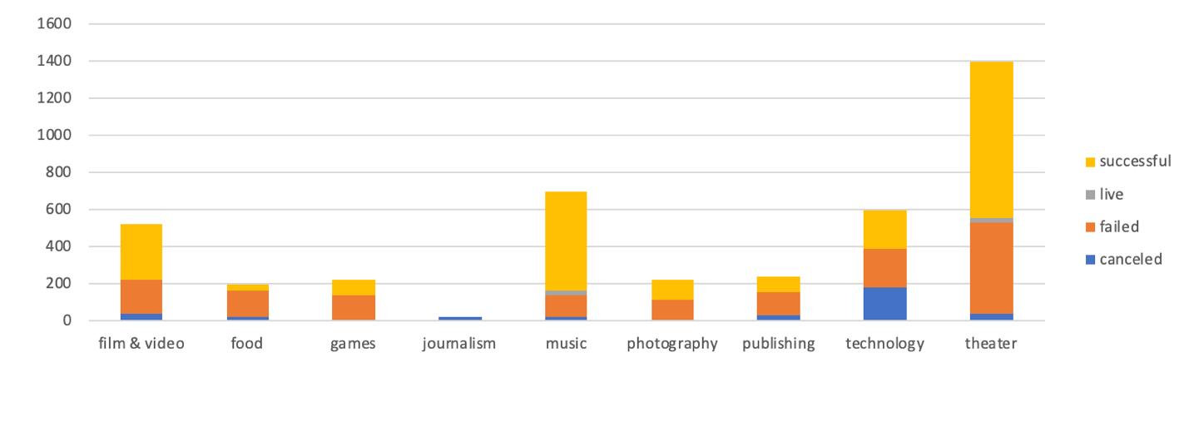

However, Music had a higher success rate at 77% compared to Theater’s second-best 60%.

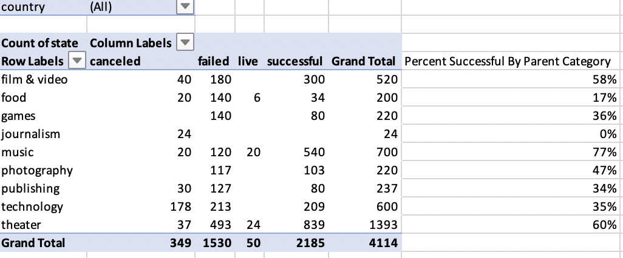

1. Within the Music subcategory, Rock (260 successful out of 260), Pop (40 for 40), and Electronic (40 for 40) were categories that had perfect success rates.

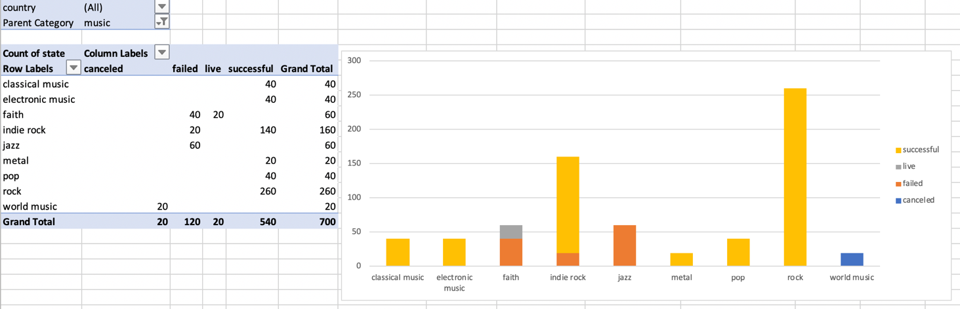

Jazz and Faith music did not see the same success. (Note: No Hip-Hop/R&B in the data?)

1. Projects with higher goals were less likely to be successful.

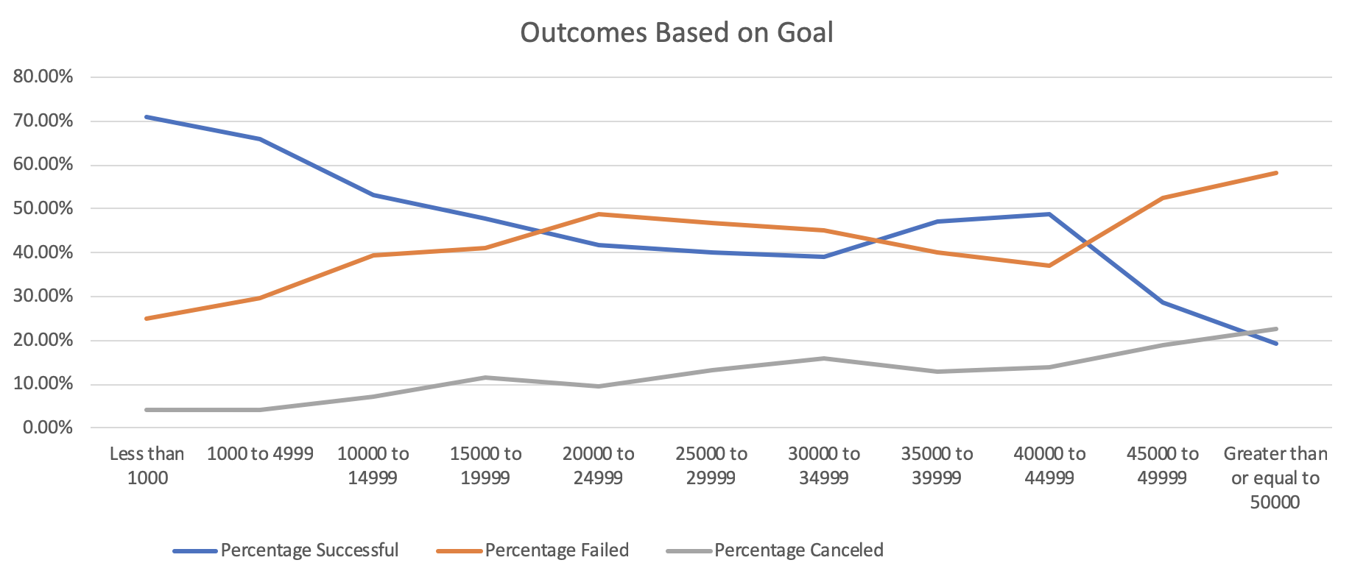

It appears that the public’s willingness/ability to crowdfund a project doesn’t scale favorably for more expensive projects.

1. Some limitations of the data include that the subcategories are rather broad and don’t give us the whole picture. For instance, we could conclude from this data that doing a kickstarter based around the Rock subcategory would be a very lucrative venture, although it may be harder than it seems. Perhaps most successful Rock kickstarters are built around making collectors edition vinyls of old classic rock records, something we can’t do unless we have the rights to a classic rock band’s discography. Getting the licensing rights would cost a lot and defeat the point of the exercise. Also, just as it is hard to classify food as “Italian,” it is hard to classify subgenres of rock or music that crosses genre lines.

Also, scrolling through the data, there is a high positive correlation between projects that have “spotlight” and projects that are successful. Are projects only spotlighted if they are successful? Do kickstarters pay extra money to get spotlight on the Kickstarter website? Perhaps there were plenty of viable campaigns that didn’t make it because the site did not give it exposure. Knowing the relationship between “staff_pick” and “spotlight” to the rest of our data could give us a better picture of the overall story.

1. I think a pivot table ranking each subcategory by its success percentage would give us a better idea of what type of projects do well and which ones don’t. Also, creating histograms examining the relationships of average donation size to success rate and number of backers to success rate could give us an idea of who are target market is. Do we want to promote our kickstarter towards as many people as possible, or do we want to focus our efforts towards targeting wealthier investors?